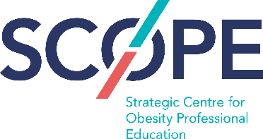

University College Dublin
Conway Institute of Bio-molecular and Biomedical Research,
Seminar
Healthcare cost-reduction and improved quality of life with
evidence-based weight-loss in diabetes and osteoarthritis
Tuesday 16th April 2019, 11:00 – 13:00

Programme:
Welcoming remarks
Professor Carel le Roux, University College Dublin
Total Diet Replacements and why they deliver more weight loss and other benefits than conventional diets
Anthony Leeds, bariatric physician, Central Middlesex Hospital, England, on behalf of TDMR Europe
Obesity and diabetes threaten European quality of life and regional health and social care budgets
Mike Lean, University of Glasgow, Scotland
My successful use of Total Diet Replacement for weight loss followed by weight maintenance and diabetes remission on the DiRECT programme
Joe McSorley, Paisley, Scotland
PREVIEW-study and prevention of type 2 diabetes
Mikael Fogelhom, University of Helsinki, work package leader on EU 7th Framework funded PREVIEW project
Obesity and osteoarthritis – a double blow for Europe’s elderly people
Henning Bliddal, Director, Parker Arthritis Institute, Copenhagen, Denmark
The clinical and cost effectiveness of a community based total diet replacement weight-loss programme
Nerys Astbury and Seamus Kent, University of Oxford, England
Q/A Session
Concluding remarks by Professor Carel le Roux, University College Dublin
*A networking lunch and drinks will follow the event.

